**SysOps Tools AWS (Amazon Web Services) Basics**

**Name: Lavish Sharma**

**Batch: 9**

Sprint - 1 (Assignment – 1)

**Task:** Create user and give that user specific permission; login to user account and check if you are able to use that resource and see if other resources/ services are accessible or not.

Install AWS CLI and create a policy using AWS CLI.

Please take the screenshots of what you are doing and your CLI outputs, and paste it in a word file and share before tomorrow session.

1. To create a user, first login to your AWS account and click on **Management console**.

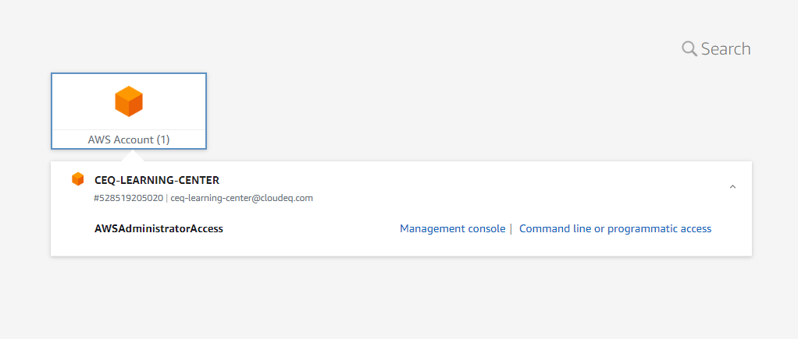

1. Console Home will open, then you need to search for IAM and select **IAM**.

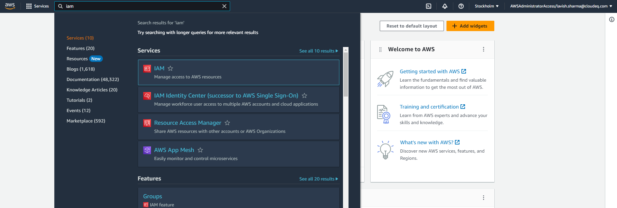

1. After that IAM Dashboard will open. Now select Users inside Access Management on the sidebar.

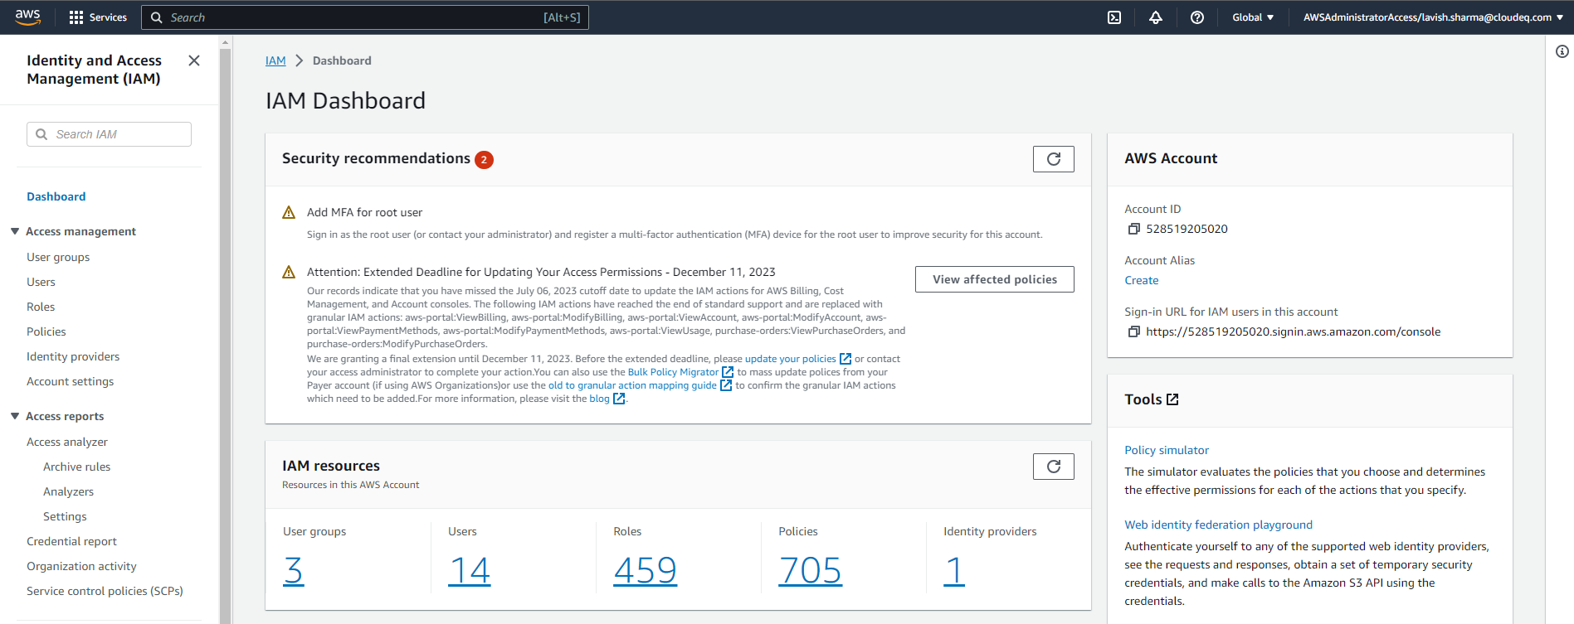

1. List of users will be visible to you. Now to create a new user, we need to click on **Create User** on the top right side of the console.

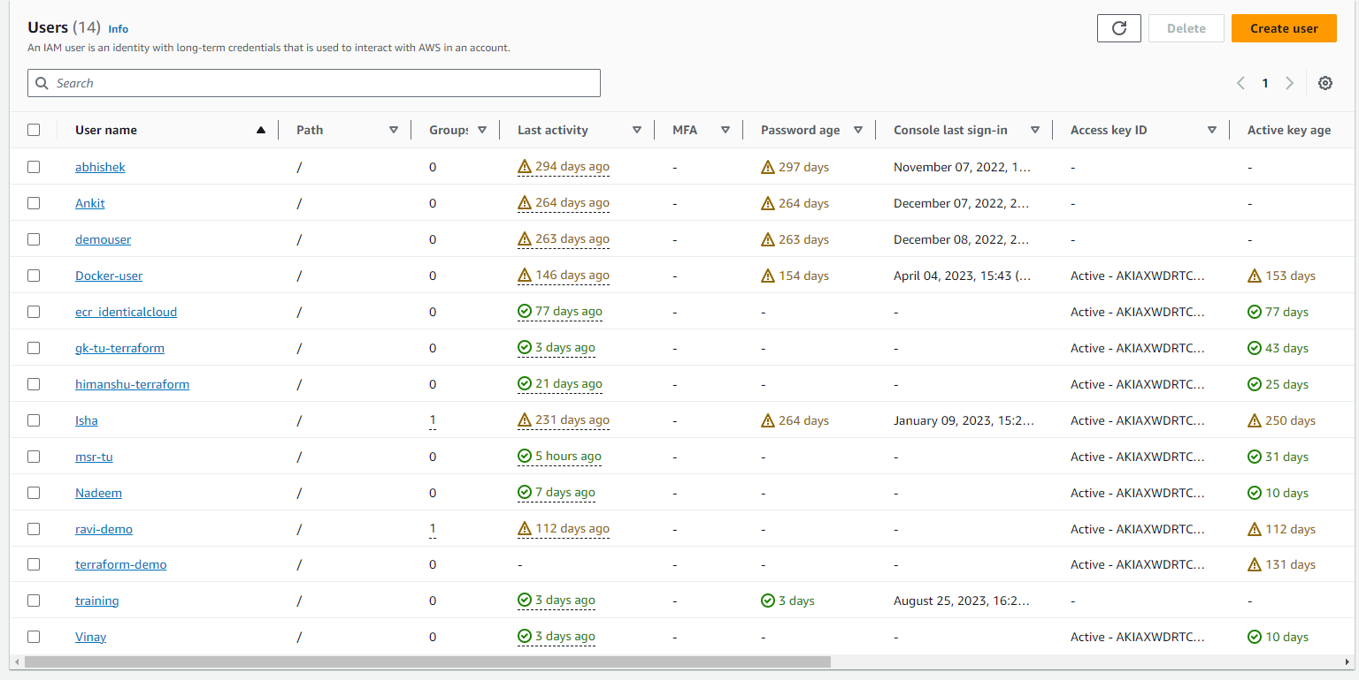

1. Now create user interfaces will open and you need to specify User Details like Username, Console Password and click next.

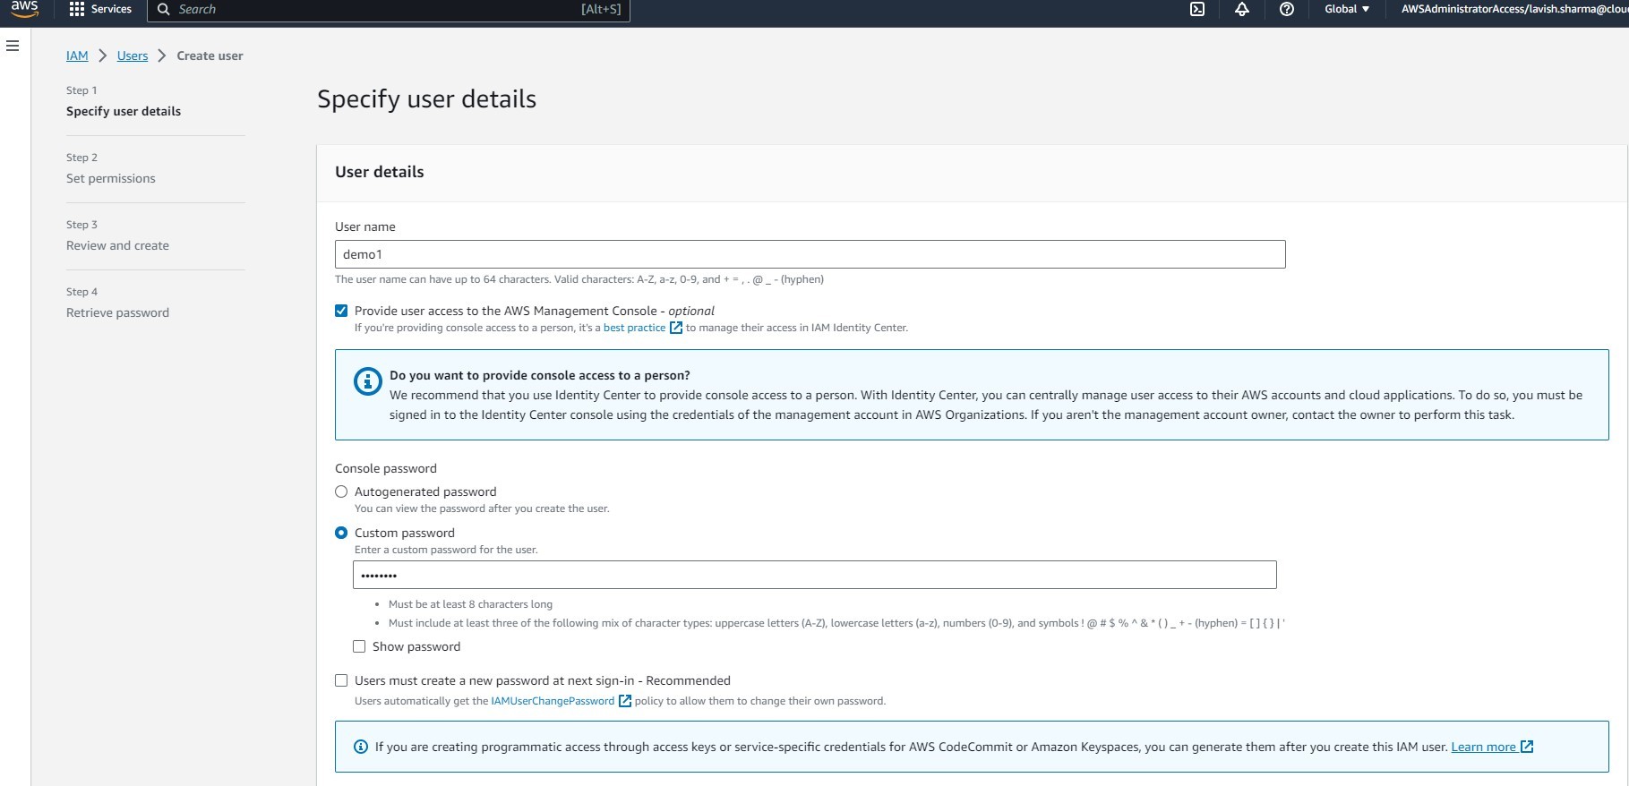

1. Now we need to set permissions for that new user. Search for permissions to give and select and then click next. In this case we gave this user **AmazonS3FullAccess**.

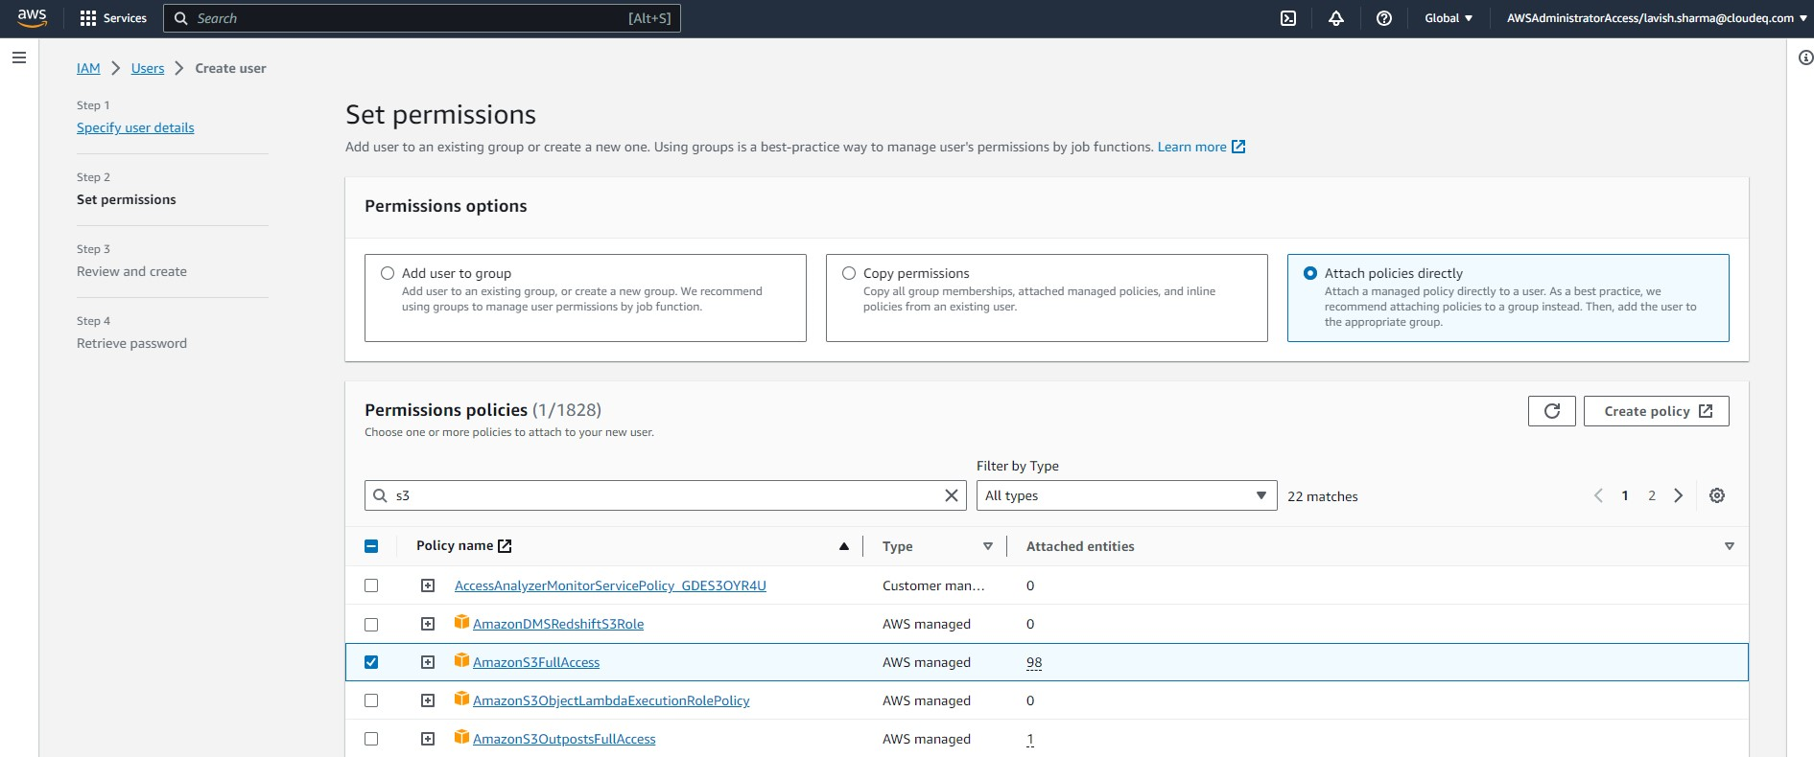

1. The last step is to retrieve sign-in details and a new user is created.

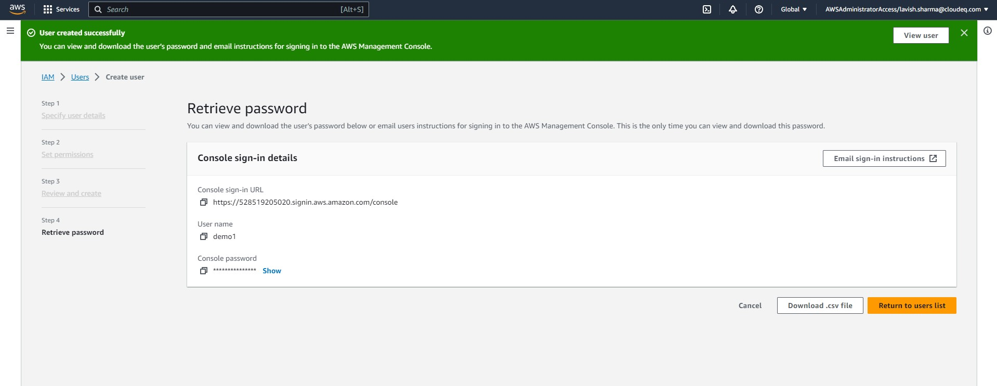

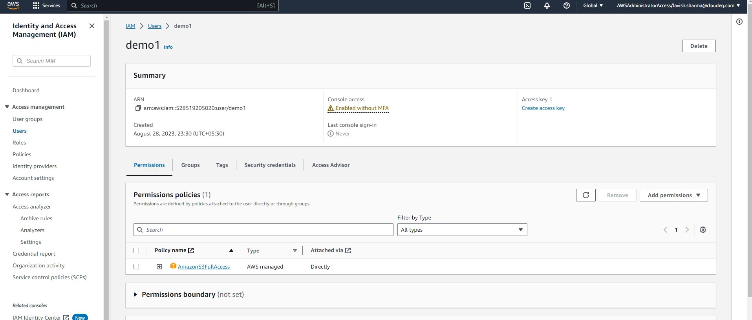

1. Now to log-in to a newly created user, first open **incognito window** and open Sign-in page to log-in IAM User and enter all required details and click Sign in.

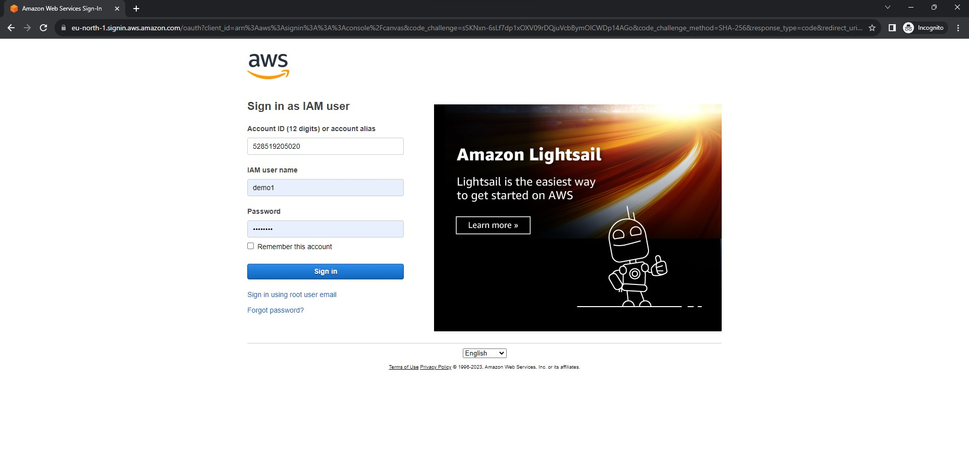

1. As we gave **AmazonS3FullAccess** permission to this user, we are going to create an **S3 Bucket**. Search it inside the search section and open it.

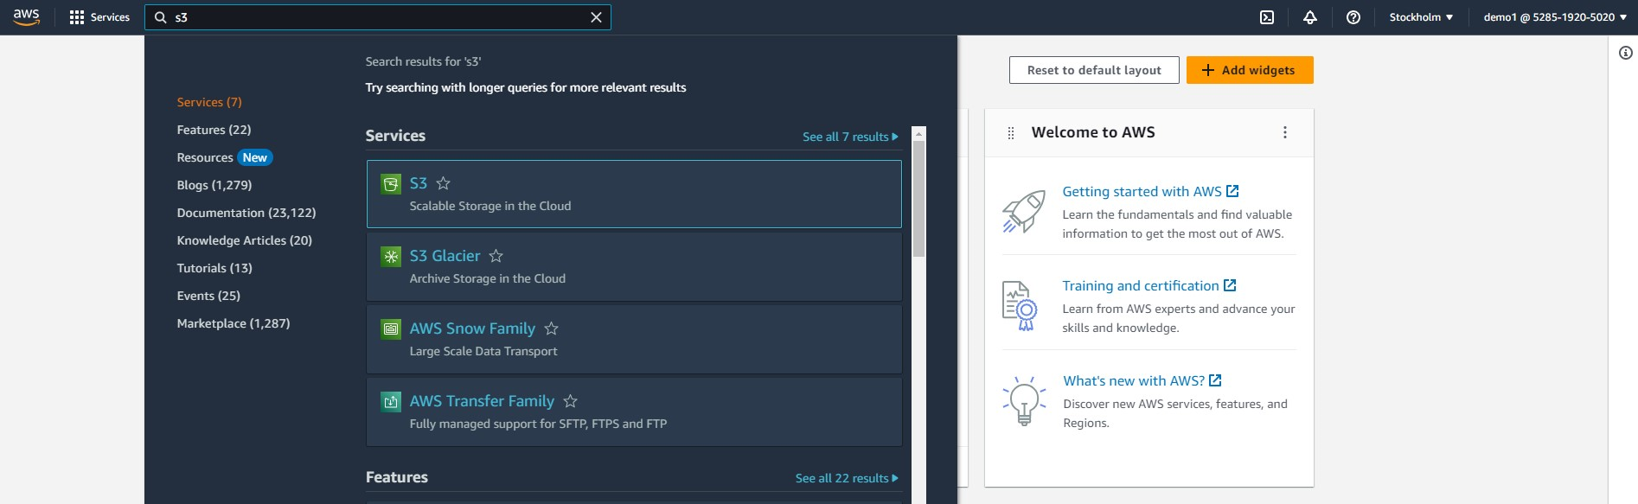

1. Now click the **Create Bucket** button to create S3 Bucket.

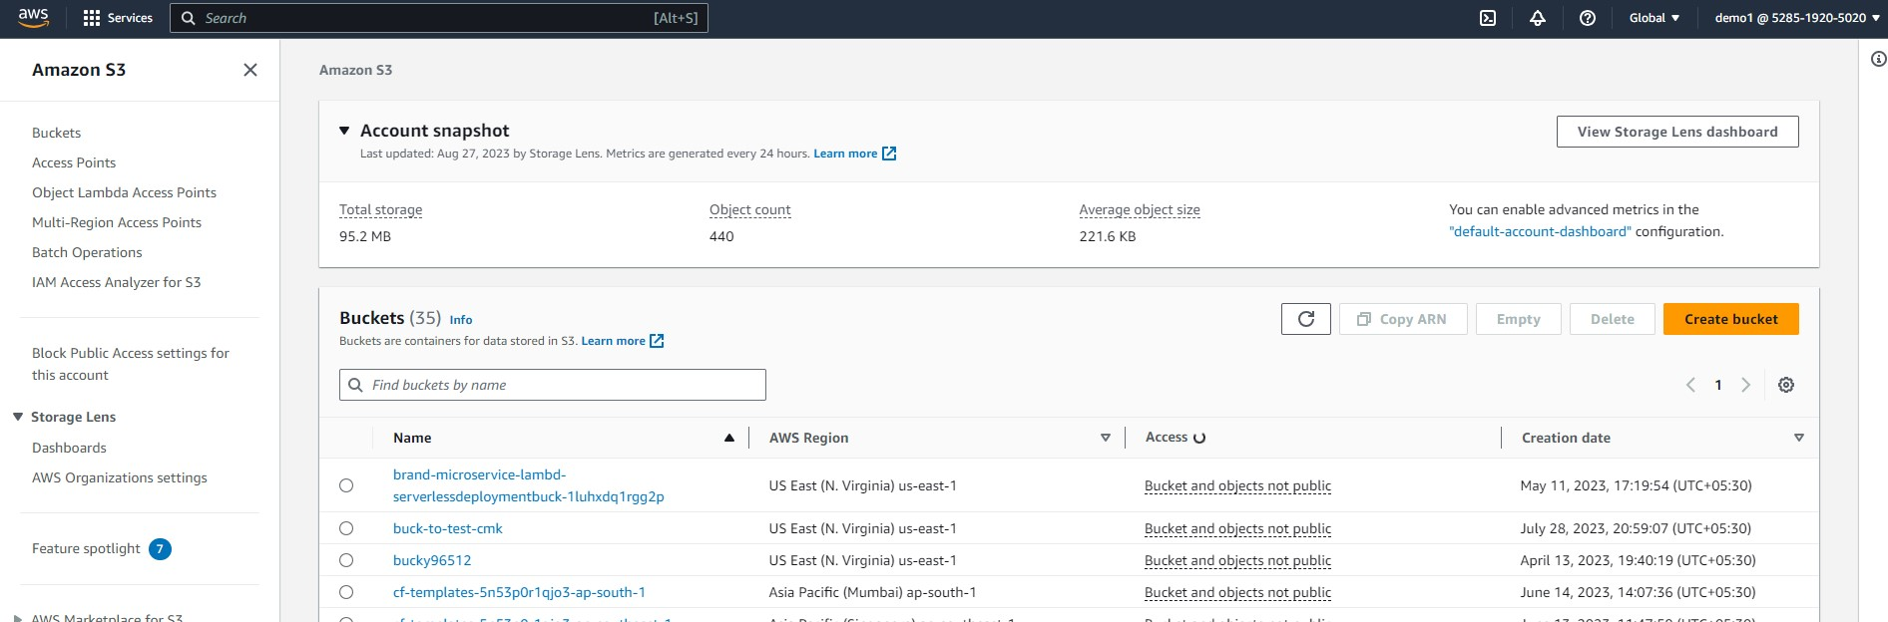

1. After that we need to configure the bucket and specify some details like Bucket Name (should be globally unique). After specifying everything click on **Create Bucket**.

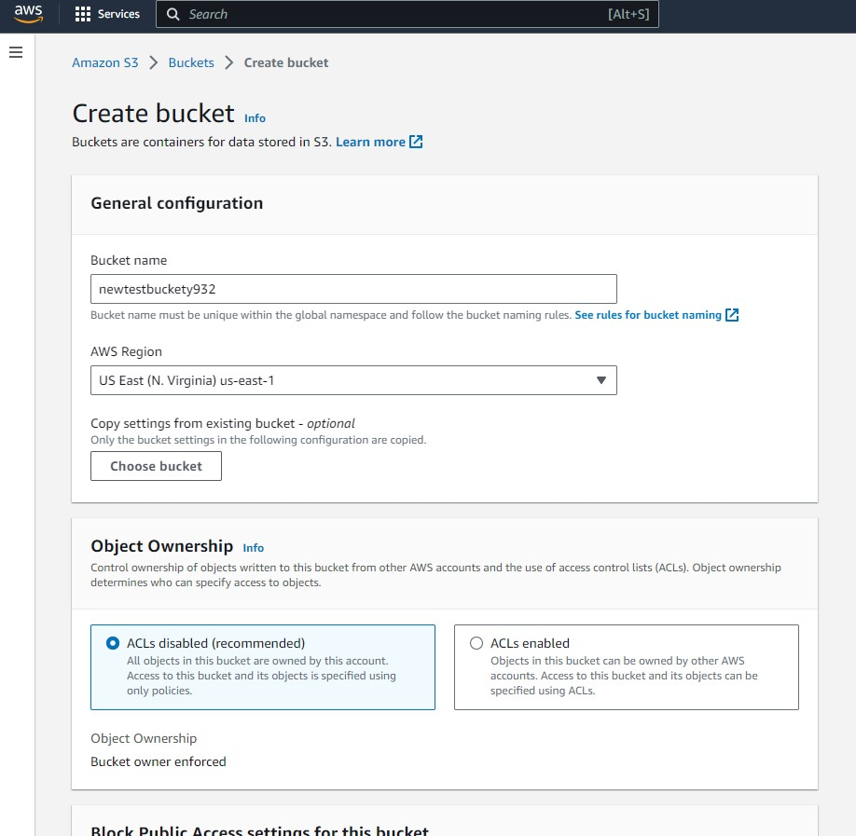

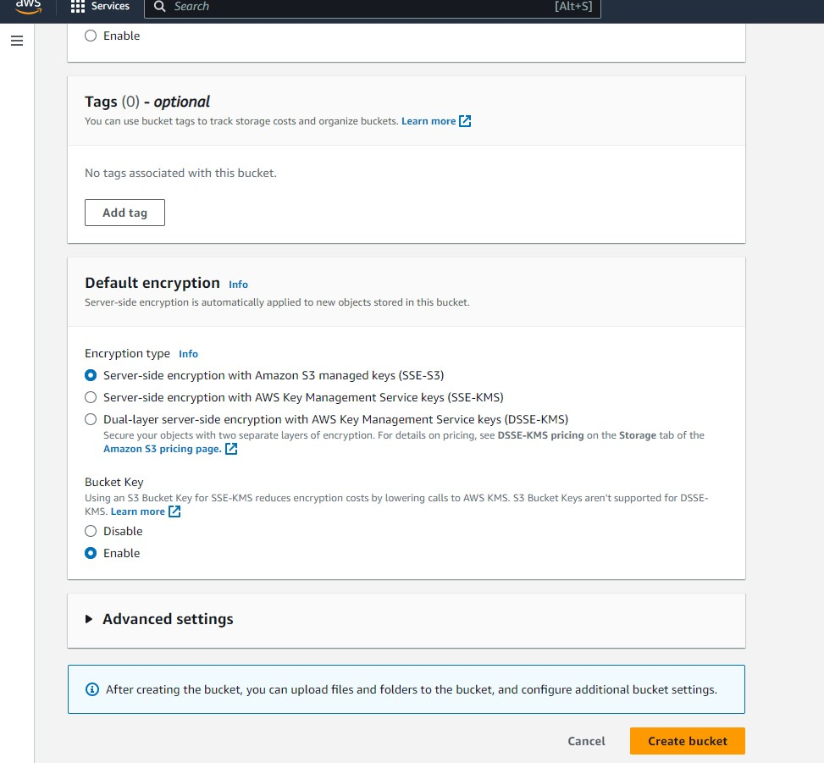

1. We successfully created an S3 Bucket named **“newtestbuckety932”.**

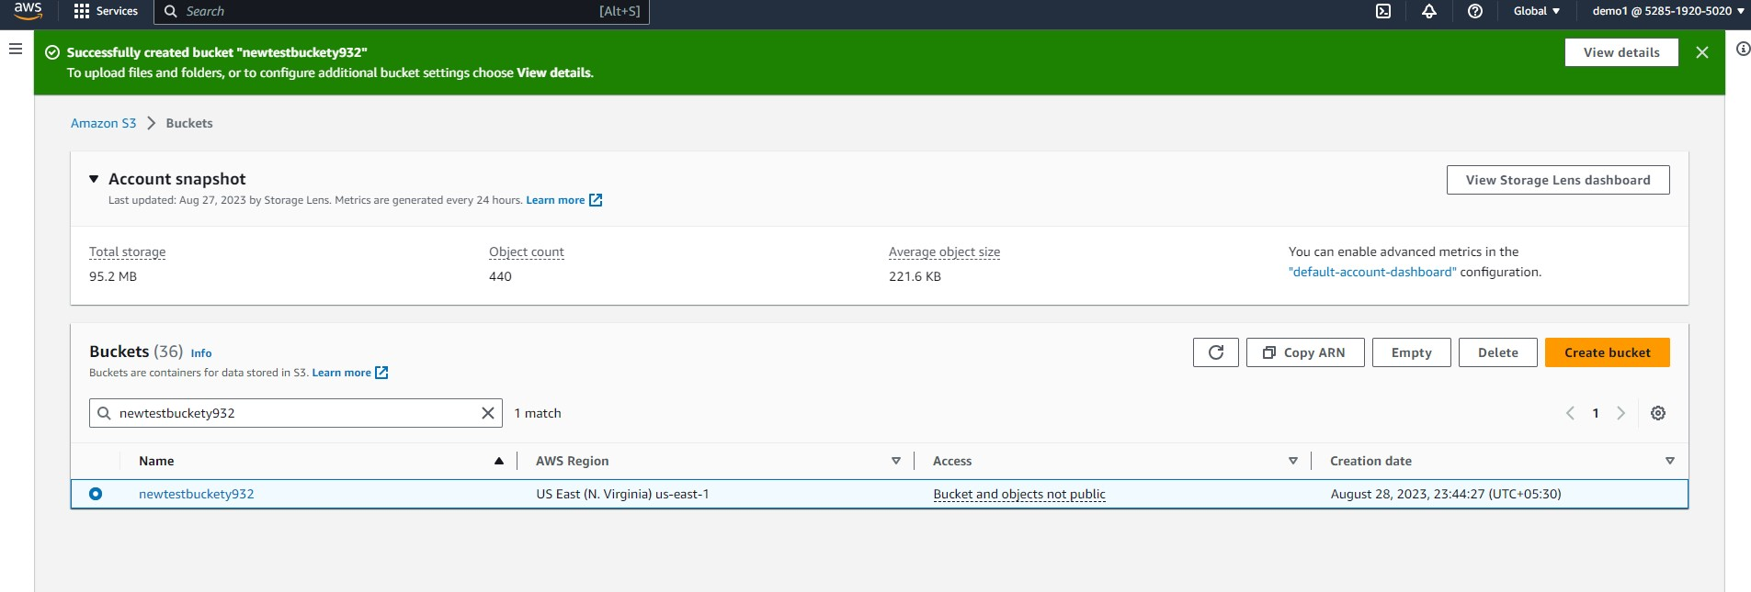

1. We can delete a bucket as well. To delete we can click on **Delete** and a new window will open to delete bucket.

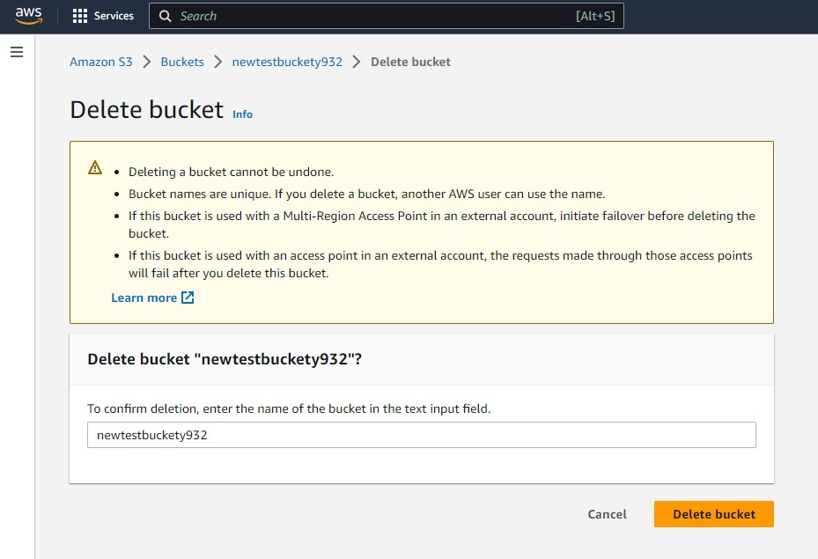

1. We successfully access S3 Bucket and make changes using newly created user.
2. Now again search **EC2** to create new virtual server.

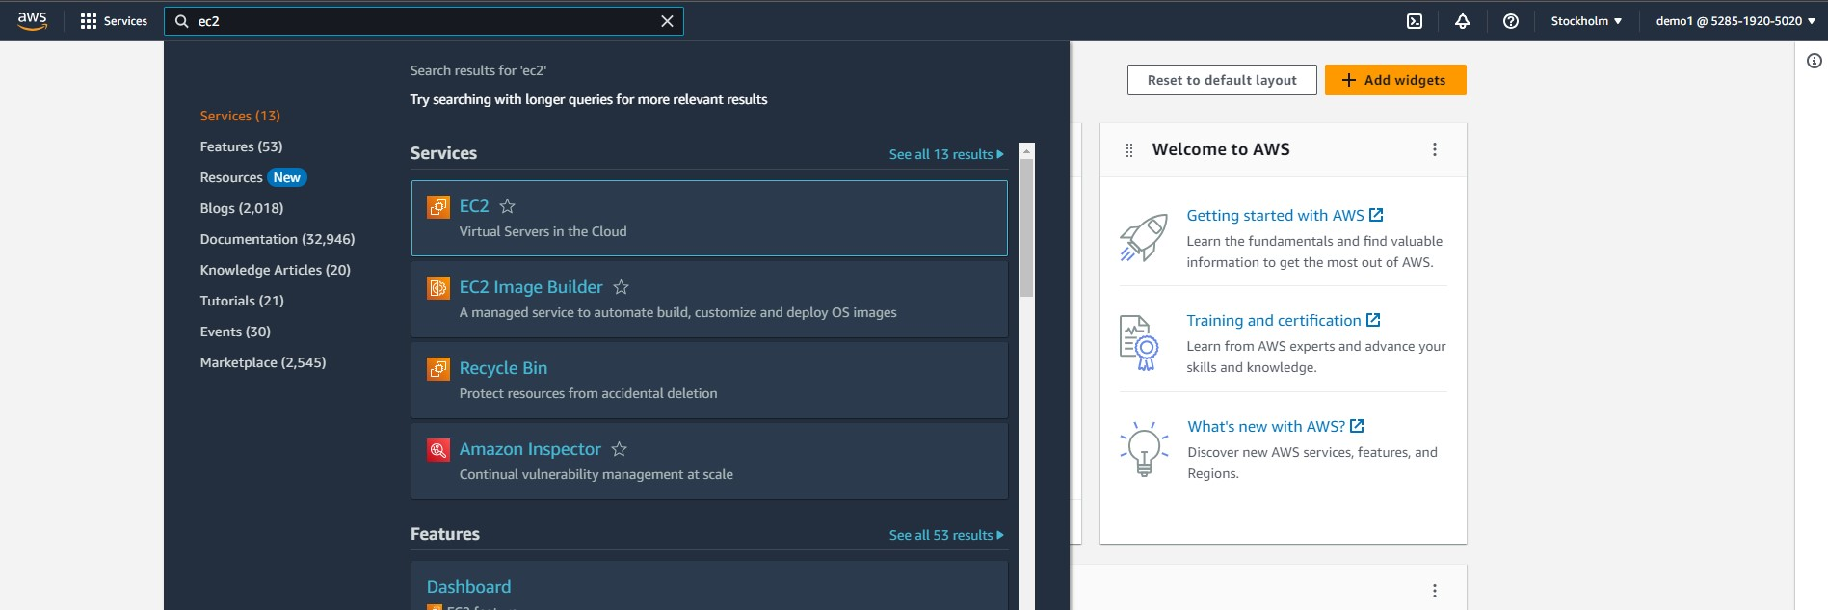

1. Now to Launch new EC2 instance, click on **Launch Instance**.

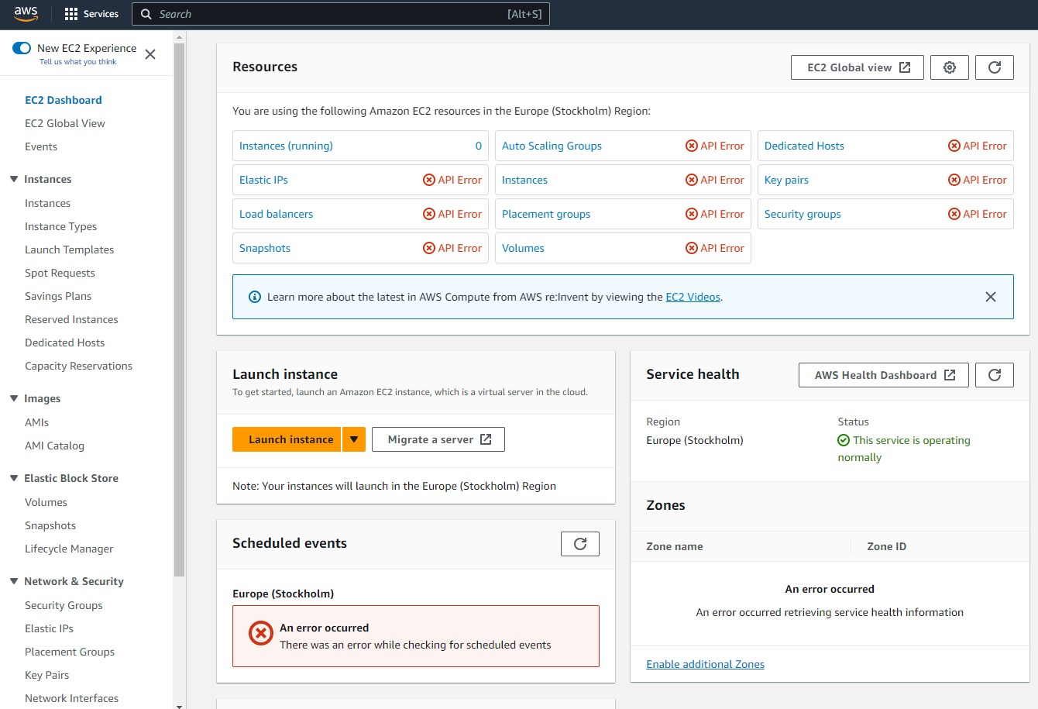

1. Now to provide Name and tags to it but our newly created user doesn’t have permission for EC2. So, we cannot create a new EC2 instance.

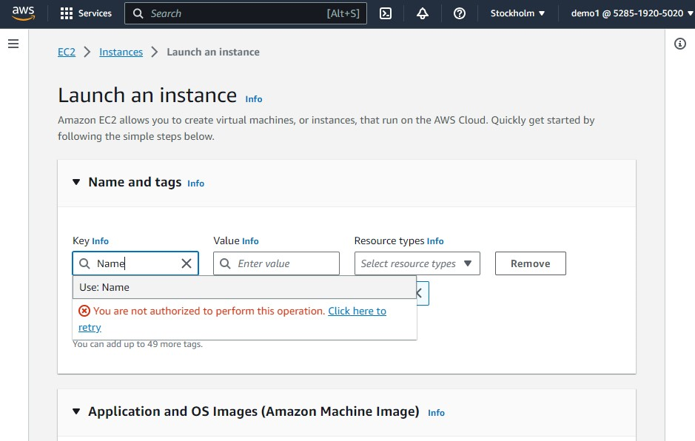

**Install AWS CLI and create a policy using AWS CLI.**

1. Now to install **AWS Command Line Interface (AWS CLI)**, go to [**https://docs.aws.amazon.com/cli/latest/userguide/getting-started-install.html**](https://docs.aws.amazon.com/cli/latest/userguide/getting-started-install.html)
2. And depend on OS select section, in our case we are using Windows. So open Windows section and there is a link to download AWS CLI for windows.

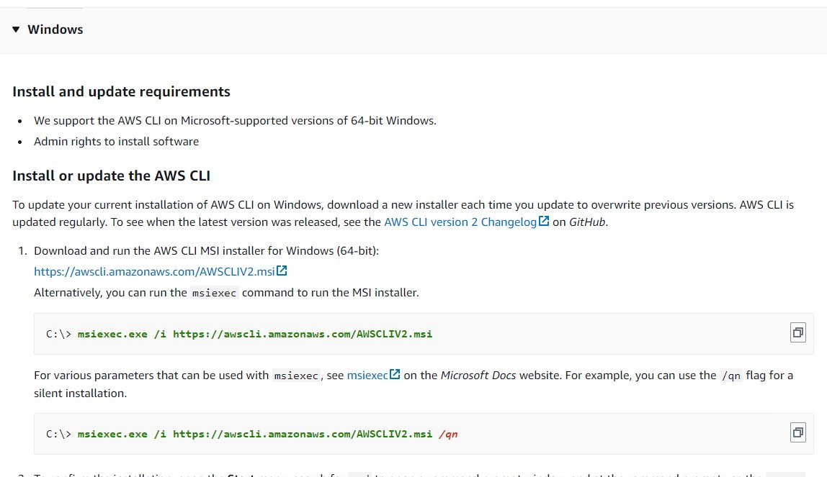

1. After downloading, we need to install it. Open it and click next to install.

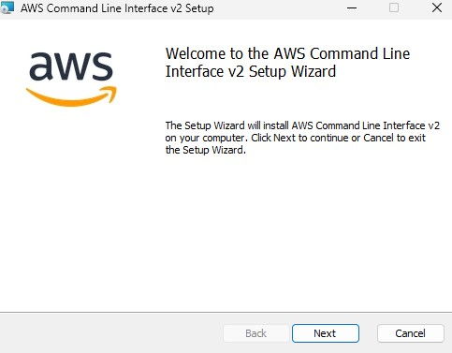

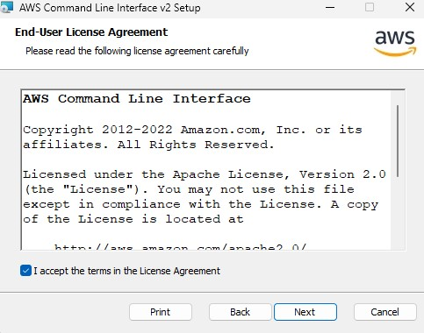

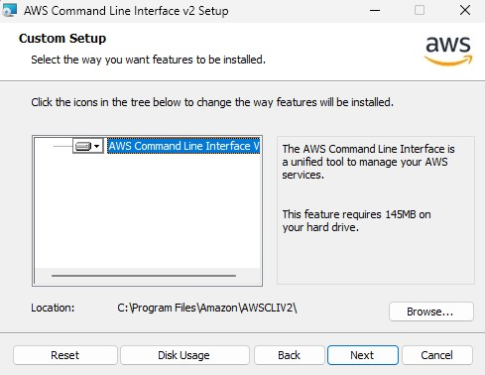

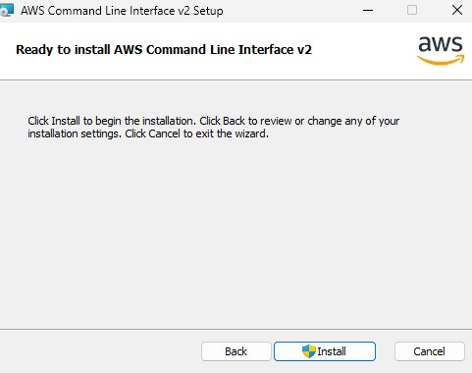

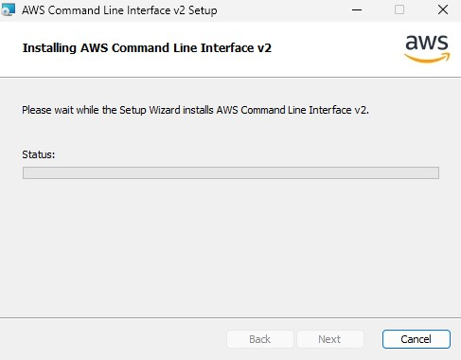

1. After installation of AWS CLI. Open command prompt by searching **“cmd”** on start button. And type command **aws --version.** It will show the current version of AWS CLI.

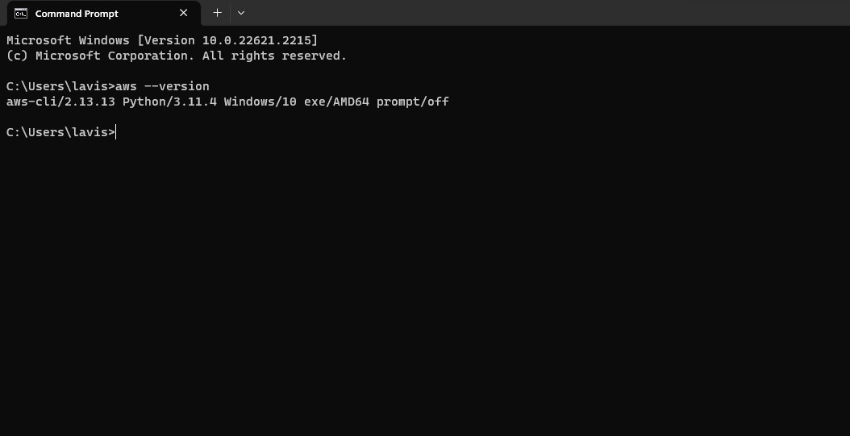

1. Now on AWS console click on **Command line or programmatic access**. It will display credentials to connect AWS with our Command Prompt.

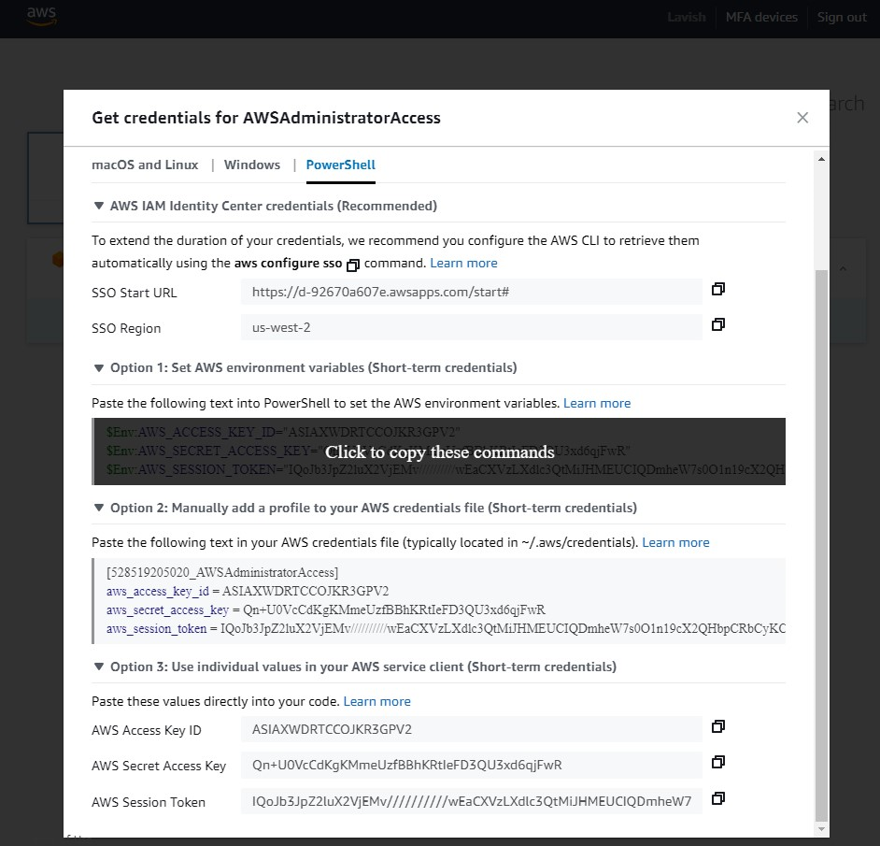

1. Copy them and paste them in the terminal and hit enter.

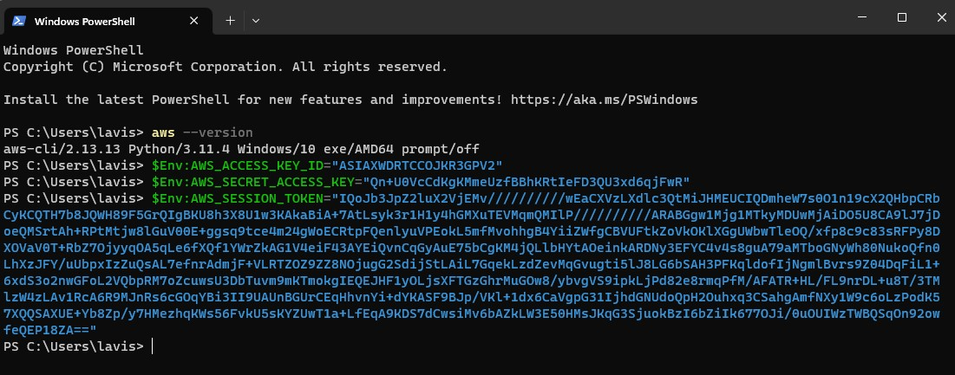

1. Now to create a policy using AWS CLI, we need a JSON file which includes all configurations of our policy to create.

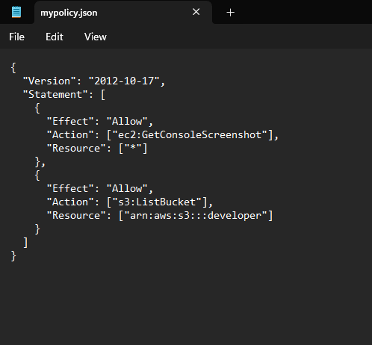

1. After creating JSON, save it and copy its path.
2. Now to create policy, we need to type a command

**aws iam create-policy --policy-name <NAME OF POLICY> --policy-document file://<PATH OF JSON FILE>**

And hit enter.

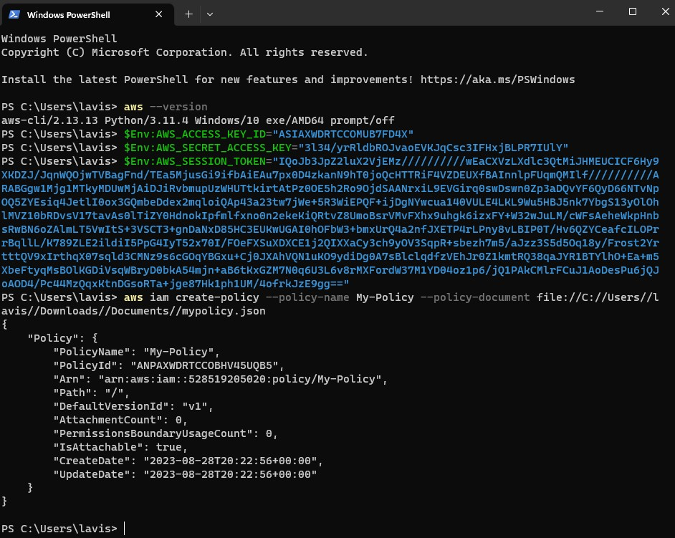

1. Now open **AWS Management Console** and Search for **Policies** under IAM. Then search for newly created Policy under Policies. In this case the name of our create policy is **My-Policy.**

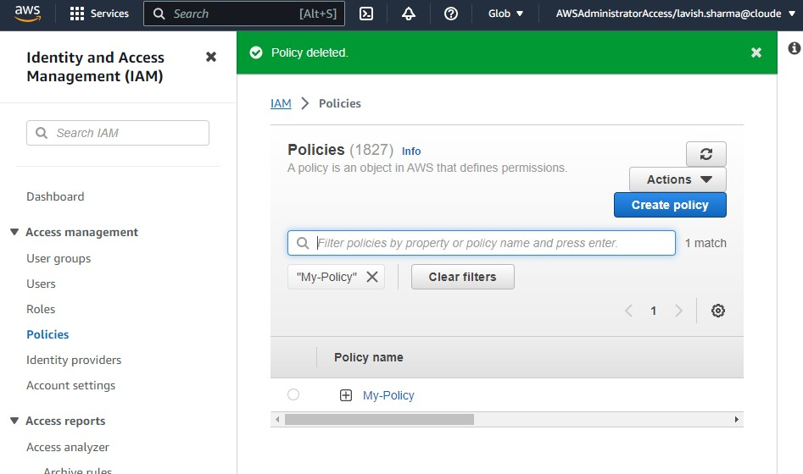

We have successfully created a new policy using AWS CLI.